Муниципальное бюджетное общеобразовательное учреждение
Средняя общеобразовательная школа № 67
с углубленным изучением отдельных предметов

МЕТОДИЧЕСКАЯ РАЗРАБОТКА
урока по английскому языку в 9 классе
«Conflicts and Youth»

Автор: Ваторопина Е.В.,
учитель английского языка
высшей категории

Екатеринбург
2012
Материалы данной методической разработки могут быть использованы в работе над темой «Conflicts» в 9 классе, а также при подготовке и проведении итоговых уроков по данной теме. Применяются интерактивные методы обучения. Большое внимание уделяется исследовательской деятельности учащихся и использованию ее результатов на уроке.

Тип урока: Дискуссия-конференция

Цели урока:
- развитие коммуникативных умений учащихся: умение слушать и слышать собеседника;
- развитие навыков публичного выступления, уверенности в себе;
- развитие логического и критического мышления;
- использование результатов проектной деятельности на уроке;
- воспитание терпимости к различным взглядам, чувства уважения к собеседнику;
- создание устойчивой мотивации к учению.
Задачи урока:
- создание коммуникативной среды для обучающихся;
- обеспечение учащихся учебно-методической разработкой урока (раздаточным материалом).

Ход урока:
В начале урока ставятся цели и задачи. Для раскрытия темы используются современные технологии, методы и формы обучения, базирующиеся на коммуникативной основе.
Good-afternoon, dear friends!
I’m glad to see you – our students and guests of our conference.
Today we have gathered together to speak about conflicts: their different types, about conflicts, which are the most important for young people. We shall discuss the ways of how to resolve conflicts, and of course – how to avoid or prevent them. You’ll share opinions about your own experience and your thoughts on this topic.
Let’s begin.
- Warming up. Topical vocabulary. Dialogue Vocabulary
to agree  to discuss  to choose  to disagree  to understand  to argue  to share  to hear  to lead to  to relate  to solve  to unite  to prevent  to avoid  to ignore  to confuse  to criticize  to support  to hear  to differ from | to respect each other  to listen to each other  to talk to each other  to deserve somebody’s love  to observe the laws of co-existence  to get on well  to suggest an idea  to allow  to discriminate  to prohibit  to suffer from  reserved  polite, calm, kind  friendly  optimistic  tolerant  aggressive  nervous | values  rights  relations  opinion  idea  situation  conflict resolution  by peaceful means  in a peaceful way  reunion  fair  unfair  argument  violent  confident  attentively  similar  calmly  friendship  freedom

Dialogue Vocabulary

In my opinion …  I think …  To my mind …  What do you think about it?  It’s a good idea to …  I feel strongly against it.  I’m absolutely positive that  I don’t care about …  Do you mean that …?  I’m not sure that …  I’m sure you’ll agree that …  In addition to that … | For example …  For instance ..  First … Second …. Third …  The first … The second … The third …  First … Next … Then … After that … Finally …  Connecting words:  Consequently … Therefore … However … Because of …  Although … In addition … Since … Also …  Because …. … so … … but … …

- The first question we’ll answer is “What is conflict?”
Explain what conflict is. Explain why conflicts happen.
Возможные ответы:
It’s a state, a situation, when people quarrel, argue, may be fight with each other.
Conflict is an opposition of needs, values and interests. A conflict is a struggle between people. The struggle may be physical, or between conflicting ideas.
Psychologists and sociologists say that there are five basic ways of solving conflict:

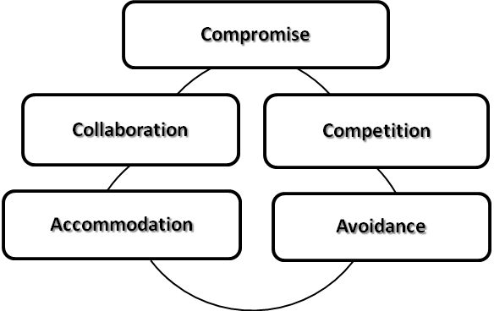

And every person decides himself what way to choose, if he really wants to resolve conflicts.

3. Let’s speak about conflicts.
Questions for discussing are on the screen. Let’s read them first.
Give an example of your conflict, your own experience – with your classmates, friends or parents. Рассказы учащихся о себе.

Is a peaceful resolution important? Explain why?
- Look at the screen. These sayings maybe will be able to help you to avoid or to resolve conflicts. I’ll give you these cards with some interesting sayings. Read, translate them paying attention to the underlined words. (карточки)
Begin each day with friendly thoughts, And as the day goes on, Keep friendly, loving, good, and kind, Just as you were at dawn. Frank B. Whitney
Plant Kindness and Love will grow. etc.
Can you recommend a book about peace-making and explain why this book is helpful? Use one or two of the “clever thoughts”.
I’d like to recommend you this book. The title of the book is «Язык разговора». Here you can find interesting and important information about how to talk to come to an agreement, how to behave when you are criticized, how to pay compliment and avoid conflicts.
- Project work – presentation of pupils’ research projects
I think it will be interesting for all of us to learn what your schoolmates think about conflicts. Your classmate held the investigation connected with this topic. And now she will tell us about the results of her research work. Listen to her and then you will be able to ask her any questions you are interested in.
Содержание результатов исследования проекта «Conflicts in teenagers’life»:

To achieve the aim of our project we held the investigation. We asked our schoolmates (9-10 forms) some questions connected with the topic.

Questionnaire

- How often do you have conflicts?
- Constantly
- Often
- Sometimes
- Seldom
- Never

- What are the most common causes of conflicts?
- Misunderstanding
- Lie
- Betrayal
- Bad mood
- Rivalry
- Envy

- Whom do you often have conflicts with?
- Close friend
- Friends

- Classmates
- Parents or relatives
- Teachers
- Boyfriend/girlfriend
- Who else?

- How do you resolve conflicts?
- I take the blame on myself
- I compel somebody to be sorry to me
- I undertake nothing
- I arrange a fight
- I make a compromise
- Your variant

- Is it possible to avoid conflicts?
- Yes, always
- Yes, in most cases
- Sometimes
- Seldom
- No

According to the results of the questionnaire, a lot of girls sometimes have conflicts. It is normal, because there are no teenagers living without conflicts. About 35% often have conflicts, and only 12% of girls constantly have conflicts. In my opinion these results are connected with problems at school, in a family and between friends.
Misunderstanding is the main cause of conflicts in girls’ life, but also 27% of girls have conflicts because they have a bad mood today.
About 14% think that lie is important cause of their conflicts, and they
Investigation
The results of the questionnaire

Girls, 9-10 form

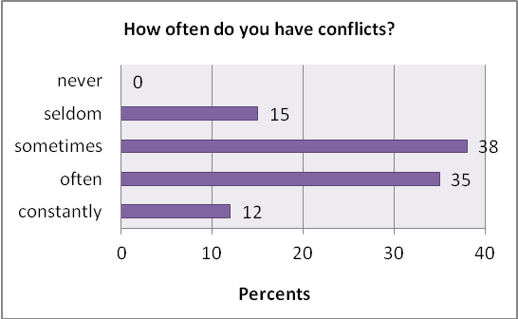

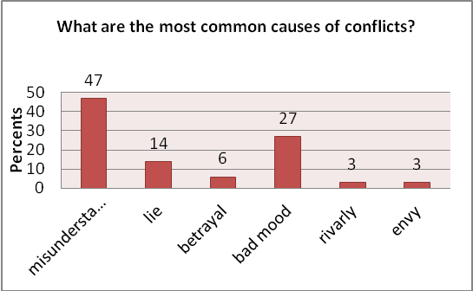

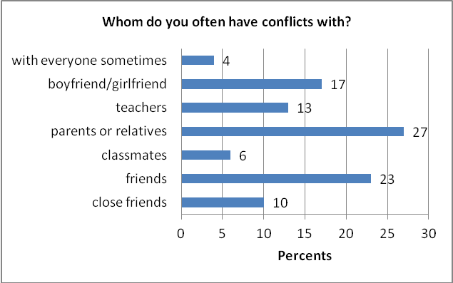

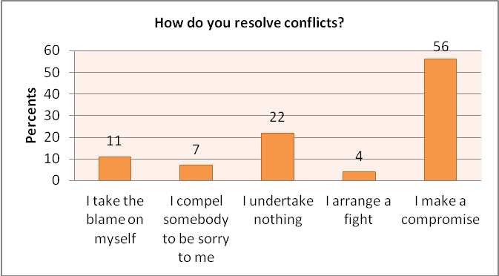

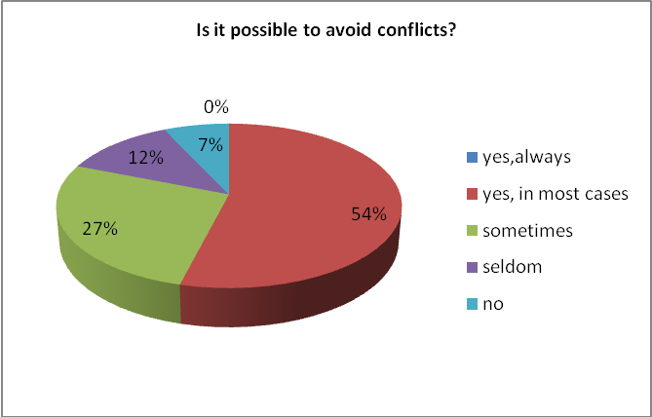

Boys, 9-10 form
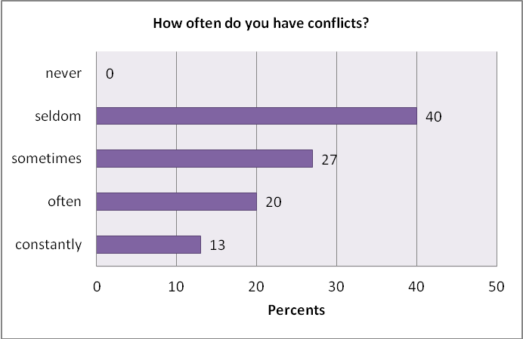
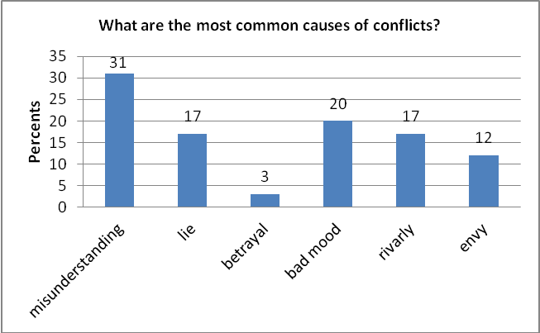
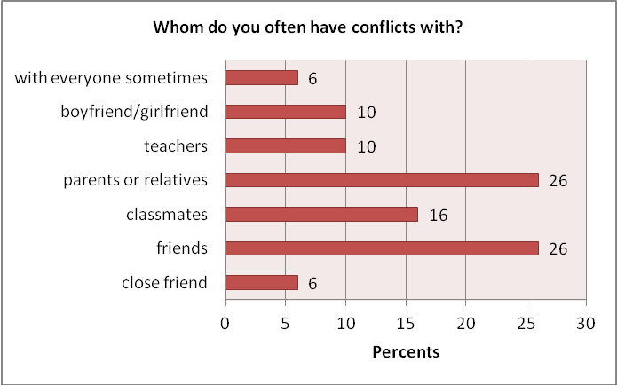
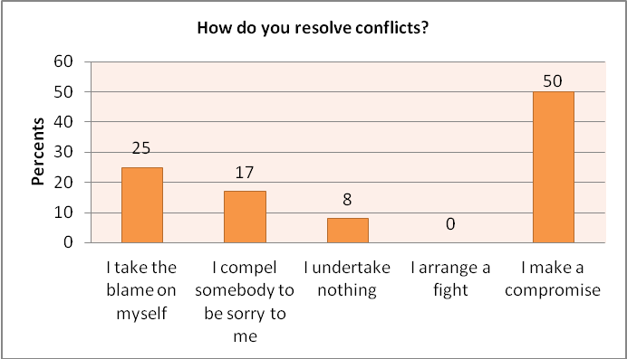
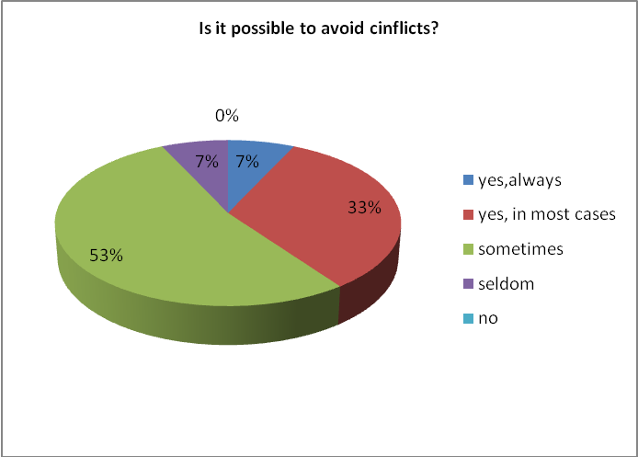
are right. Many of my friends and relatives hate when somebody lies. And only 3% of girls say that rivalry and envy are common causes of our conflicts.
27% of girls often have conflicts with their parents and relatives. About 23% have conflicts with friends, because girls usually argue about fashion, films, music, boys and their friendship. 17% of girls have conflicts with their boyfriends. Girls are very nervous, tender and delicate, therefore they need support, attention and love. 13% also have conflicts with teachers, because girls do not agree and are upset about their marks at school. 10% of girls have conflicts with close friends; they have faith in best friends and want to know everything about them.
About 56% of girls make a compromise if they want to resolve conflict. 22% undertake nothing in conflict situation. I think it is not good, when you don’t control situation. 11% of girls take the blame on their selves. Only 7% compel somebody to be sorry to them, it is bad trait of character. These girls are very artful, impudent and haughty. And 4% of girls (!) will arrange a fight if they want resolve their conflicts. Why not?! I can’t denounce their actions. May be they are very sporty and brave girls.
About 54% of girls think that it is possible to avoid conflicts in most cases. It is very positive mood and this is praiseworthy. 27% say that it sometimes is possible to avoid conflicts. 12% of girls think that it seldom is possible. And about 7% of girls say that it is not possible toavoid conflicts. They are very pessimistic, because in my opinion everybody can avoid some things. You need only want to change your life to the best.
Boys are calmer than girls. About 40% of boys seldom have conflicts. It is good, because these students spare their nerves. 27% sometimes have conflicts. But 20% of boys often have conflicts and 13% constantly have conflicts. I think these statistics are unwell. It means that teenagers are very irritable and high-strung. It is connected with modern mode of life for children and juveniles.
Misunderstanding is also the main cause of conflicts in boys’ life. 20% of boys say that the most common cause of their conflicts is bad mood. About 17% think the main causes of conflicts are lie and rivalry. Boys trust their friends and hate liars. Boys complete with peers in sport, studying, minds, etc. 12% of boys think that envy is important cause of their conflicts, because envy is terrible feeling. If someone envies you, you will feel unwell, it’s not great.
26% of boys often have conflicts with friends and parents or relatives. These conflicts are connected with different interests and problems of generations. About 16% of boys have conflicts with their classmates, because almost each boy wants to be a leader in his class. 10% have conflicts with girlfriends and teachers. It means that some boys are selfish and contentious. 6% of boys often have conflicts with everyone, in my opinion they are very aggressive and impertinent. One day they will become adults and will understand that it is necessary to avoid conflicts in our life.
Half of boys exactly make a compromise if they want to resolve conflicts. It is good attitude. 25% take the blame on themselves in this situation. They act in a masculine way. But 17% of boys also compel somebody to be sorry to them. Maybe, there are some boys in our school, who think just only about themselves. They say that they are always right in everything. Boys are more peaceful than our girls; nobody of boys arranges a fight in conflict situation. It means that they can resolve conflicts in a peaceful way.
About 53% of boys think that it is possible to avoid conflicts sometimes. 33% say that it is possible in most cases. 7% of boys think that it always is possible to avoid conflicts. And nobody of boys says that it is not possible. I think that it is very positive. These boys are cheerful and tactful than some girls in our school, who think that it is not possible to avoid conflicts.
Conclusions. What is conflict? It is the expression of disagreement over something important to both (or all) sides of a dispute. The first important thing to grasp is that it is entirely dependent on the people involved. It depends on their having a particular point of view, which may or may not have independent facts and evidence to support it, and on how they behave when they encounter an opposing point of view. Young people have not only lack experience, but also often have little foresight. Parents should teach their teens to think like chess players: before they make a move, they should try to anticipate the consequences.

What will happen to me if I make this next decision or choice?" At the same time, parents should be asking themselves "What can I do in this situation to help my teen be more responsible?"
Many teenagers think that school spoils our childhood and takes a lot of time. But they make a very big mistake. In future people understand that the school time was the best in their lives, but it can’t return. And we also understand it, because after two years we’ll finish school, and everyone will have its own future. Sometimes I want to become an adult, because I want to see my future, but at the same time I want to be always little, to be always with my friends and parents, and never lose them, but I know – unfortunately it is impossible.
We think we should learn to be tolerant and try to understand each other and resolve conflicts in a peaceful way.
Учащиеся задают вопросы выступающим и друг другу.
- Now we shall do the exercise. (карточки)
Fill in the table, using the following words and word combinations.
Give advice on what people should do if they have a conflict.

We should … | We should not …

ask for advice from someone who is older than you
listen attentively to other people
punish unfairly
be optimistic
be confident and relaxed
bully people
criticize differences
use words like “never” and “always”
ignore someone’s opinion
keep a sense of humour
speak calmly
bully people
tell people what makes you unhappy
avoid criticizing differences

- Make a conclusion.

- To avoid a conflict we should …
- To avoid a conflict we should not …
- To resolve a conflict we should …
- To resolve a conflict we should not …
Be tolerant and you avoid conflicts!
- Подведение итогов конференции.

ТСО: компьютер, мультимедийный проектор

См. Фрагмент урока-дискуссии на школьном сайте: http://67школа.рф/index/ispolzovanie_metoda_proekta_pri_obuchenii_anglijskomu_jazyku/0-60 или на сайте http://vt-l.ru/ .

Литература:

Погосян М.А. Conflicts in teenagers’ life. http://portfolio.1september.ru, 2011 .

